IFC-ECS: A simplified IFC ECS approach facilitating IFC4.X migration
February 22, 2026
This document introduces an approach to IFC modernization based on the ECS design pattern. The core was developed during the Exton implementer’s meeting in the API group, and is being developed into a suite of data strategies, standards definitions, and reference implementations. Major elements of this development include:
- A simple data convention for migrating V4 class instances to entities and components.
- An IFC2.3 - IFC 4.0 converter, which generates IFCXJson based components from IFC files.
- A small API proposal
- A reference implementation component server that ingests legacy (2.3 – 4.0) IFC files, stores them in a local file store (so that eventually they can be gitt'ed), reads them into memory and provides offers API end points and query parameters.
- A web viewer which allows users to issue queries to servers, and navigate results.
A limited running version of the server is running (models aren’t stored and need to be uploaded)
https://ifc-ecs-prototype-daa447b4d672.herokuapp.com/
The full repo is https://github.com/Drshelden/IFCXPrototype. To run:
- set up the environment (currently .venv\Scripts\Activate.ps1 or possibly activate or activate.bat)
- run python server.py
- upload some ifc models at http://localhost:5000/
- open the viewer
- type some queries in like http://localhost:5000/api/components?models=HelloWall-03&entityTypes=IfcDoor
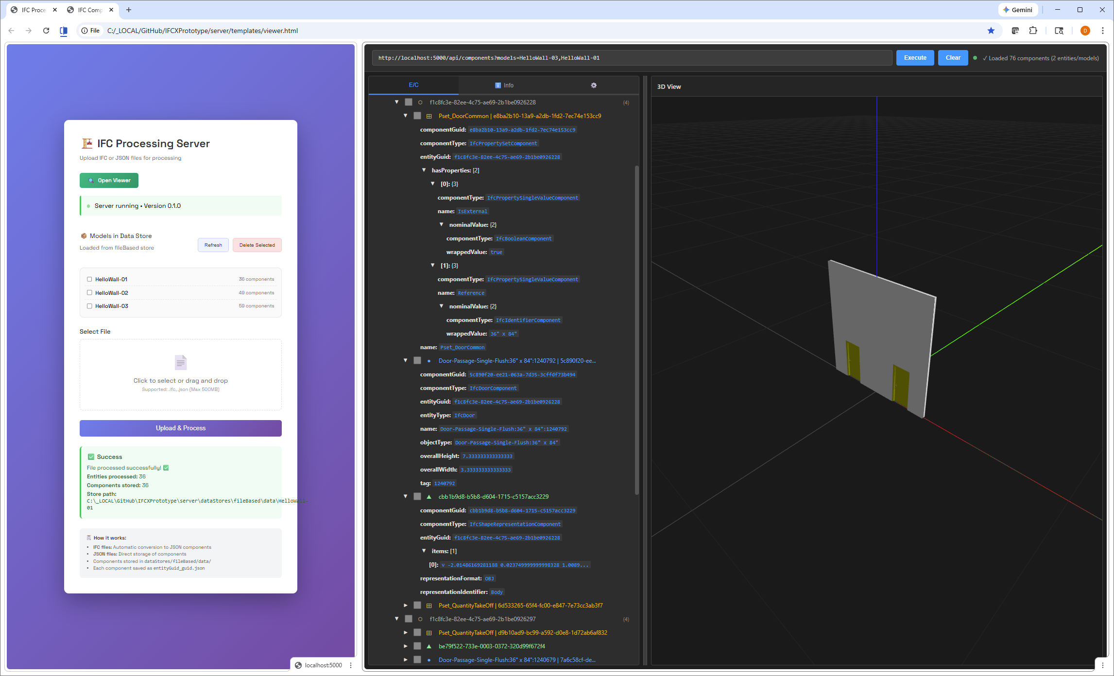
This document describes the initial assumptions and exploratory implementations and possible further developments.
- Component data format
The approach proposes a simple initial migration of IFC4X class instance data components, and a way of promoting certain IFC IDs to either entity or component Guids. Here we consider a few key class types and the migration approach, and initial tests suggest the approach can be extended to all other IFC classes. Here we consider 4 core IFC classes and their subclasses. As a general strategy,
- IFC instances are converted components, and their attributes or parameters become key / value pairs in the component dictionary. A few additional entries are added, specifically the componentGuid, componentType, entityGuid, and in certain cases an entityType that informs the system of the object type associated with the entityGuid. The IFCv4 ID is used in some cases (specifically object definitions) as the entityGuid, and in others as the componentGuid, with the entityGuid determined based on the instance type.
- Objects are selectively passed either by reference or value. As an initial rule, objects with a GlobalId are passed by reference and are “First Class Objects”, all others by value.
Object definitions
Here is a typical IFC building element definition from BSDD with the additional EC attributes and its representation as a component in Json:
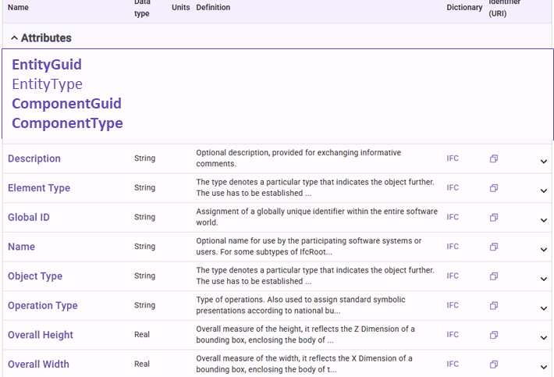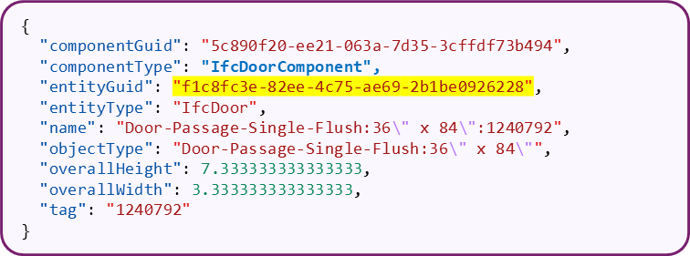
Some of the key assumptions – very much open for debate:
- The Global ID becomes the entityGuid for this component. Other components related to this entity reference this entityGuid (not one computed for them)
- A new, unique and deterministic computed Guid is created for the componentGuid.
- The V4 IFC class becomes the entityType. So far Object Definition components are unique in declaring this entityType, and these components inform the system of the type associated with the entity.
- Each component has a type, which is simply the V4 type with ‘Component’ concatenated.
- All parameter names are converted to lowerCamelCase.
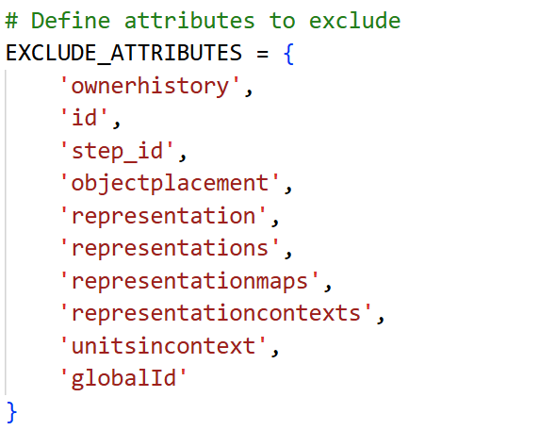
- The GlobalId and a few other attributes are removed. The list at right shows those excluded in the current converter implementation, in some cases to cull down the initially exported information pending further standardization decisions, and can be re-introduced later.
PropertySets
PropertySets are treated similarly, except their entityGuid references that of the object definition entity defined above, and the PropertySet’s GlobalId becomes its componentGuid. Like most components, PropertySetComponents do not include an entityType parameter.
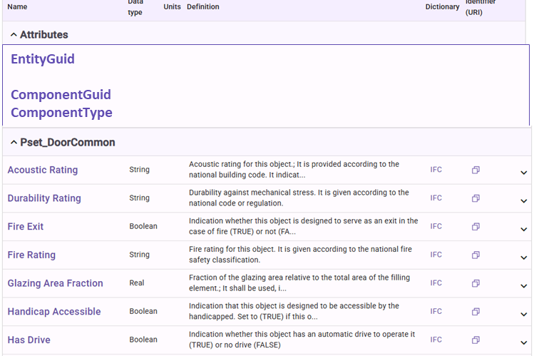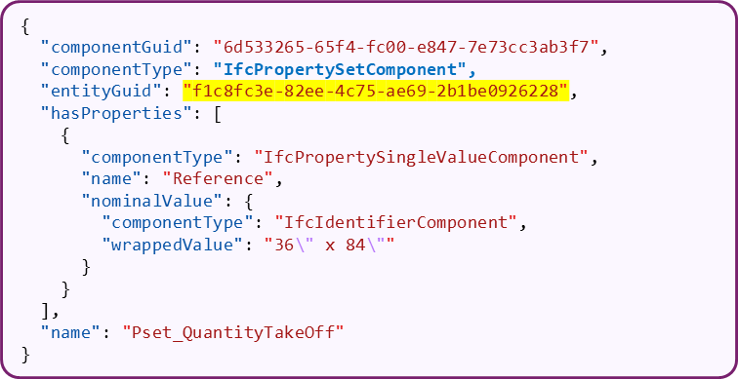
IfcRelation
There are some design decisions about how to treat entities associated with IfcRelations. The current attempt derives the entityGuid from the GlobalId of the Relating object if it exists, otherwise there is entityGuid, and the relating object is expanded into the Relating parameter’s value. Below are examples of a relationship where the Relating object is promoted to the entityGuid, and another where the Relating object isn’t first class and is expanded.
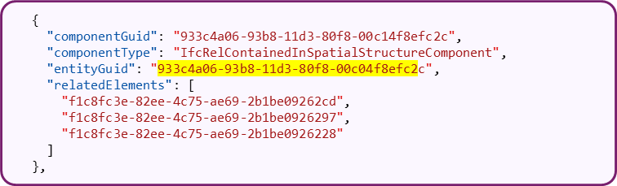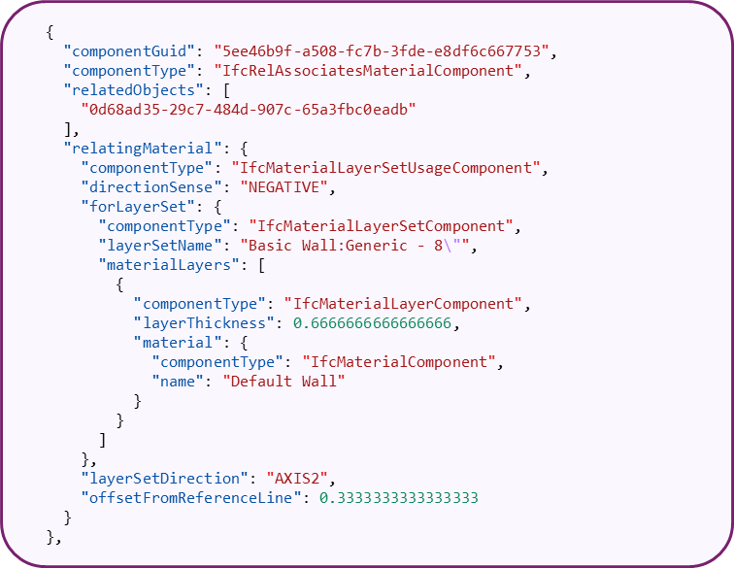
ShapeRepresentations
In the current implementation ShapeRepresentations are transformed so that they refer to the entityGuid of the object they represent. The downstream geometry is transformed into a mesh and removed (for now). The mesh is currently represented in OBJ format in global coordinates. We anticipate potentially moving to .gltf or .glb, for meshes and revisiting parametric geometry representations in future implementations/
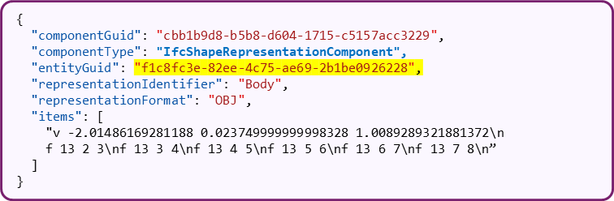

Some open questions:
- Is there a 3rd case besides First Class objects (with GlobalIds) and others that are passed by value? Should other 4X object classes be included as referenceable objects and therefore receive persistent componentGuids?
- What types of 4.X objects should be promoted to Entities?
- Can components refer to components via their componentGuids? This question emerges in the case of IfcRelations
- Which 4X classes should be included in the initial core, and how generally should classes be organized into modules.
- Other refinements of the existing 4X object classes and definitions as we go…
- Data converter
A utility that converts legacy IFC to IFC-ECS has been developed. The approach is greatly informed by the IFCJSON converter by Jan Brauer, and heavily uses IfcOpenShell. The utility can be run from the command line and is also used to ingest IFC4.X files into the server. To run:
python ifc4ingestor.py inputFile.ifc -o outputFile.json.
Note that currently the assimilator only saves components for subclasses of IfcObjectDescription, IfcPropertySet, IfcRelation, and IfcShapeRepresentation. The set of classes and parameters supported in this version is deliberately culled to remove many of the subsets of IFC objects:
- all geometries are stripped out and replaced with a triangulaged IfcShapeRepresentation,
- miscellaneous classes like Actors, Scheduled etc. are not included yet (although the current importer should generally support them - needs more testing)
- Others are filtered out simply by not including them on import (in which case they are either imported by value or simply left pointing to the IFC Guid of the relevant entity)
- “First Class entities” (with a GlobalId) are referred to by guid reference whether they are included in the export or not (ie, whether they are subclasses of IfcObjectDescription, IfcPropertySet, IfcRelation, and IfcShapeRepresentation), or are expanded as values in other cases.

- API
A simple REST API has been proposed and is implemented in the demonstration server, below. This API provides simple queries to find entity and component references and their values. The set of rest end points is documented in this API_DOCUMENTATION, API_QUICK_REFERENCE and this openapi.yaml file. The concept of a model is provisionally introduced, a model equates to a given uploaded file and its name is derived from the file name (to be discussed)
End points include:
- models #lists the models on the server
- entityTypes # lists the types of entities in the model
- entityGuids #lists the entityGuids
- componentGuidsq #lists the entityGuids
- components #returns component data
Wherever appropriate the following filters can be applied:
- models=model_01,model_02
- entityTypes=IfcType1,IfcType2
- componentTypes=IfcType1Component,IfcType2Component
- entityGuids=guid1,guid2
- componentGuids=guid1,guid2

In the proposed API and reference implementation, for entityTypes and componentTypes filters you can enter a base class like IfcProduct or IfcProductComponent and the returned values will include entires with that base and its subclasses.
Example queries:
http://localhost:5000/api/entityGuids?models=HelloWall-01,HelloWall-02
http://localhost:5000/api/componentGuids?entityTypes=IfcProduct
http://localhost:5000/api/components?componentTypes=IfcRelAggregatesComponent
http://localhost:5000/api/components?componentTypes=IfcRelAggregatesComponent
http://localhost:5000/api/components?componentGuids=156d4a9b-8c6b-d7dd-d6fc-b0dabd0b3d9c,8fcce169-98e4-9471-53dd-a583112814c7

Some open questions:
- The models concept was introduced for expediency. Does it or any container convention make sense, if so what should it be?
- This API sticks closely to basic open world Entity/Component concepts. One limitation of this approach is the need to continually search for pointing entities upstream from relationships. Within a given data store, alternative query languages maybe based on the IfcOpenShell API or the product structure would greatly simply model retrieval and navigation.

- Component Server
A demonstration component server implementing the API has been developed. This server does the following:
- Allows users to upload .ifc files which are converted to components by the IFC4.X converter, (or uploaded in IFCXJson directly). The file name minus its type is used as the model name.
- Stores the components locally. Currently every component is written out to a folder with the name "entityGuid_componentGuid.json", in the folder named by the file name of the uploaded model.ifc file. By storing this way we anticipate git-like interactions with this store. Note also that components associated with the same entity are grouped together alphabetically.
The server is developed anticipating future data stores based on GraphDB, MongoDB, etc.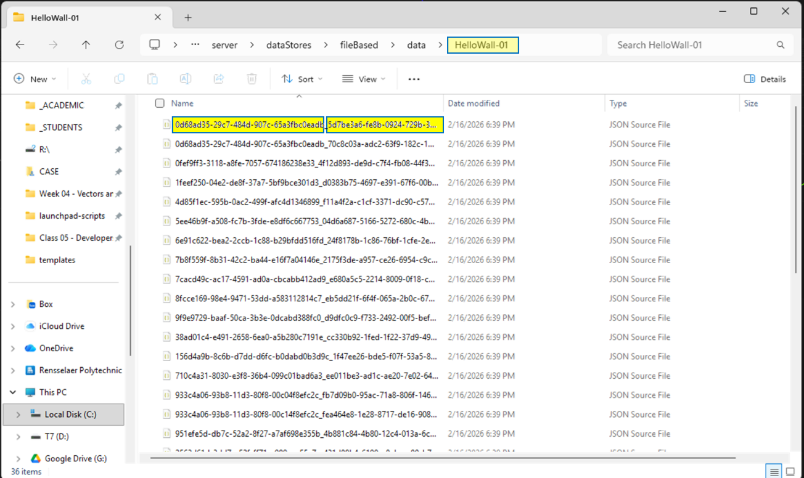
- Allows retrieval by REST end point queries, as discussed in III above.

- Viewer
A simple Web app is being developed to demonstrate the API query functionality, Entity-Component organization and allow viewing of both component metadata and ShapeRepresentation meshes. Server admin view and viewer are shown below.

In addition to the Entity/Component tree, an Info tab shows the exactly the returned results from the query.
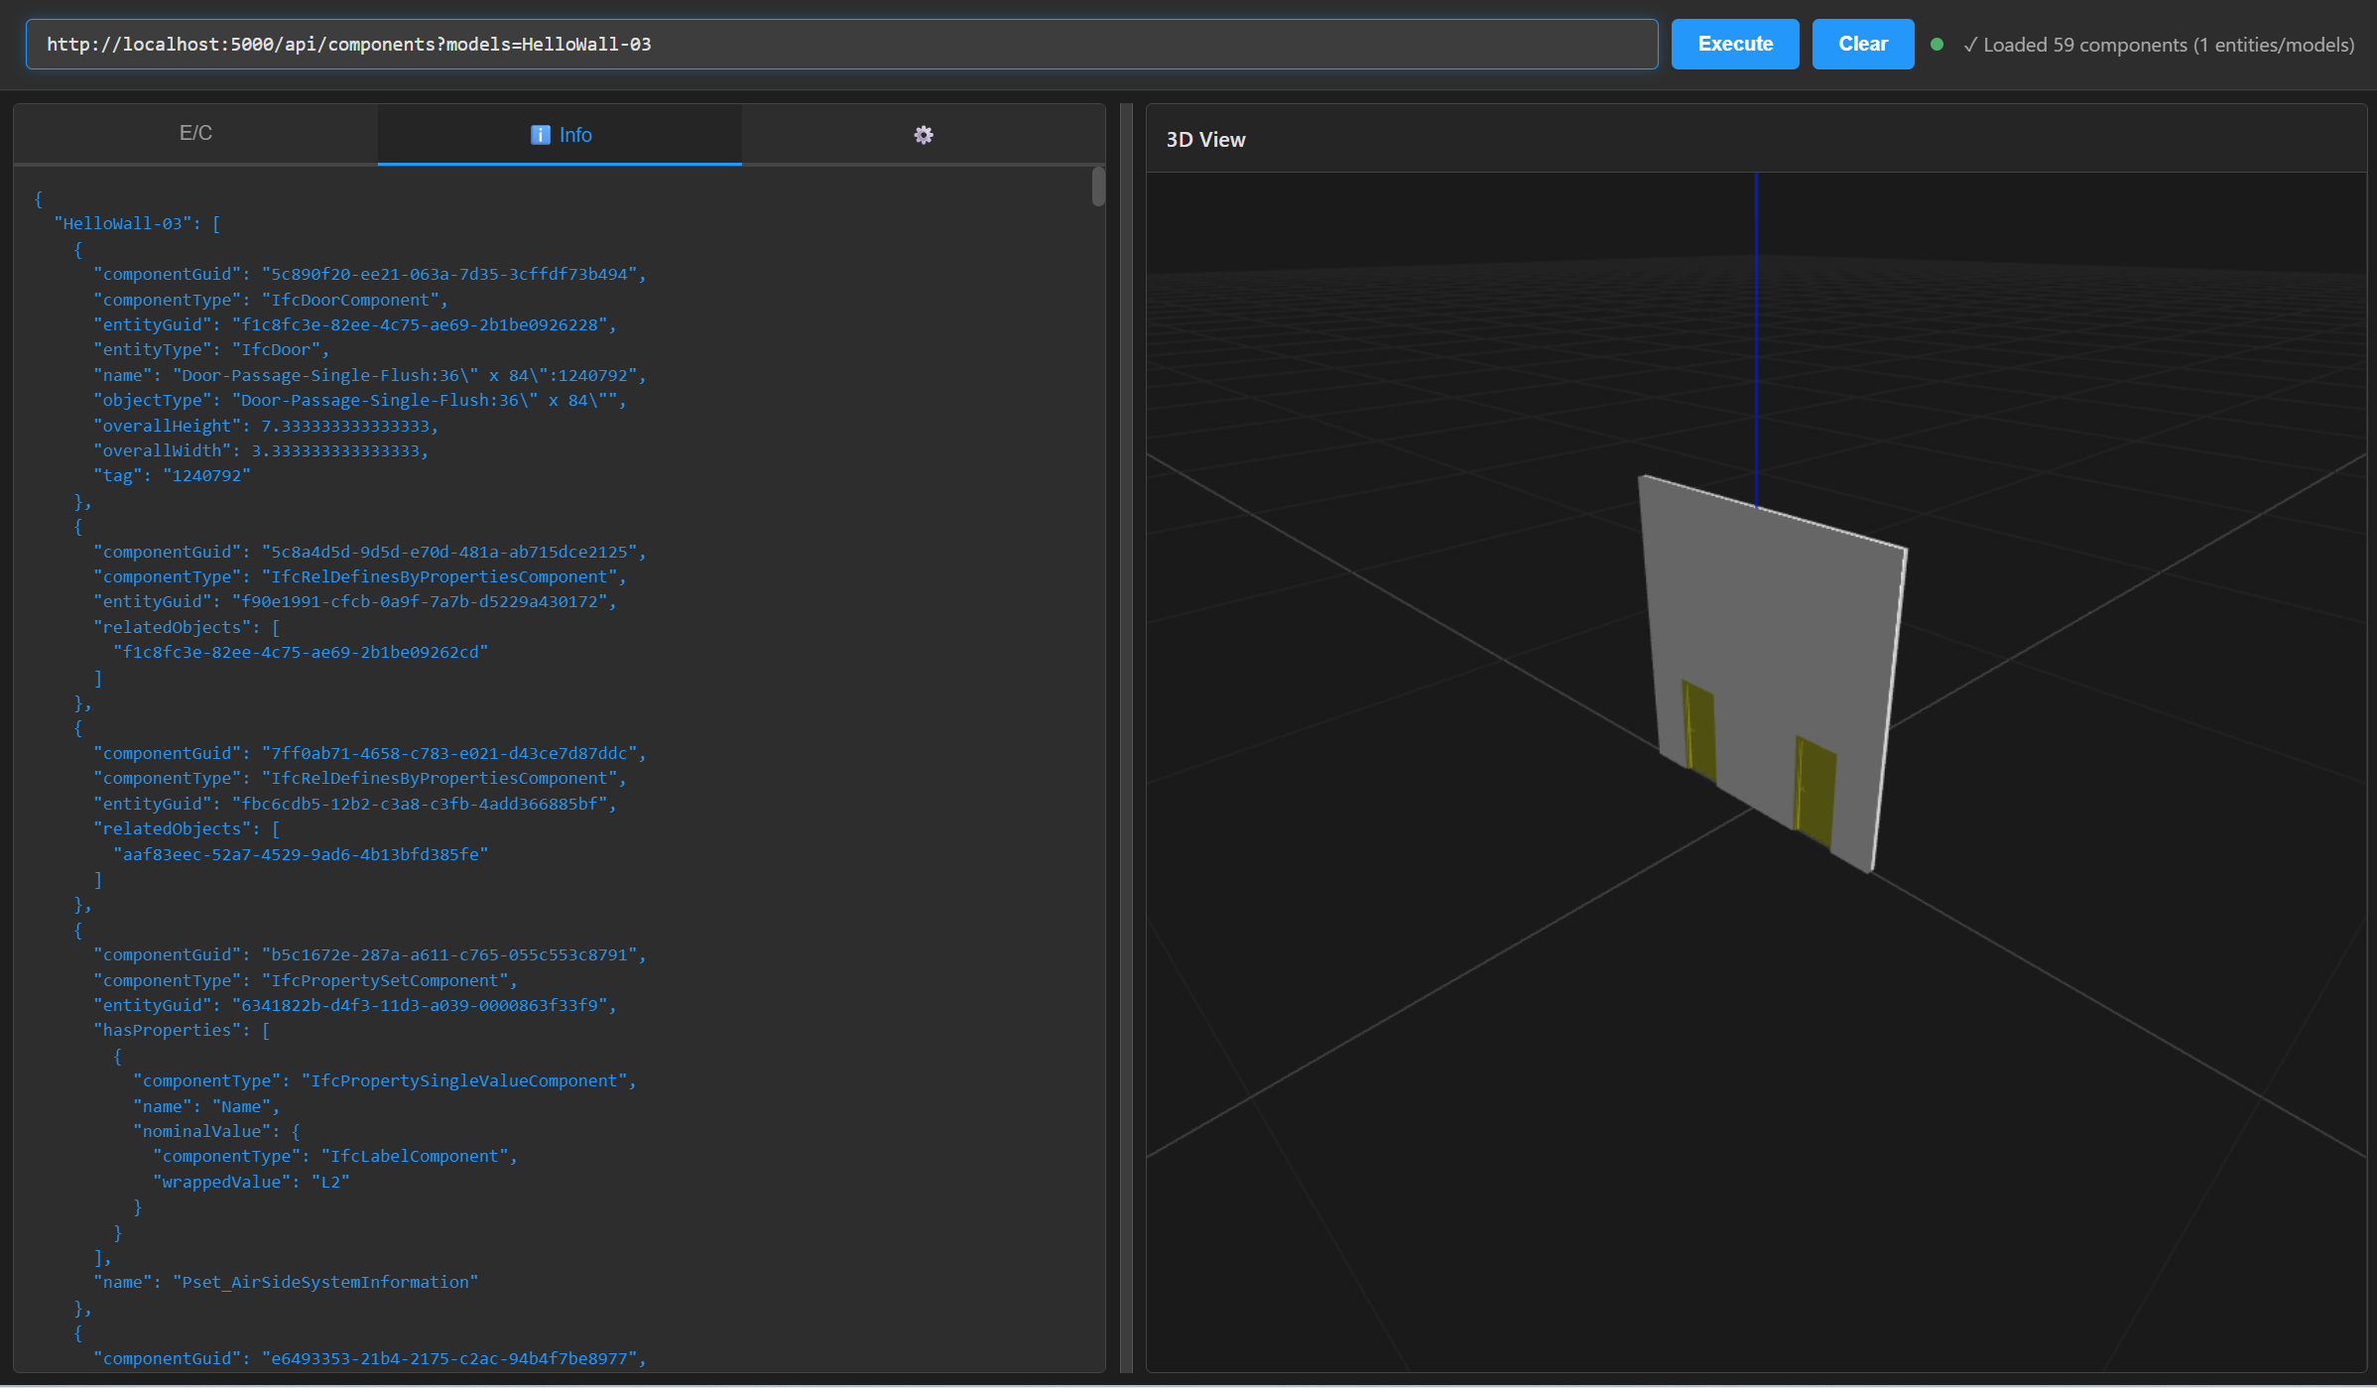
- Further work
The described prototype has been developed to facilitate discussion about a candidate IFCX data architecture and data migration strategy, and to allow demonstration and testing of assumptions. There are many preliminary assumptions and proposals that need to be considered and tested before adoption, and the current implementation suggests many areas for further work. A few are listed below. However, adopting a simplified strategy similar to the one discussed could allow rapid progression through decision making, testing and exploration by the BuildingSmart and IFCX communities.

Further topics:
- Entity and component names and name spaces. The current approach uses entityType and componentType as simple names, but no indication of their provenance is provided. An approach using URIs pointing to components’ definitions was suggested, and / or BSI could develop a name registry service a la pip, npm, etc.
- Schema modularization. Json Schema provides useful mechanisms for portioning and merging sub-schemas.
- Types and typicals. An approach based on a simple inheritsFrom or extends parameter on components has been suggested. USD may provide some valuable precedent.
- Class hierarchy and parameter simplification.
- External referencing of useful 3rd party ontologies, such as QUDT, etc.
- Alternative encodings beyond Json and REST, including JSON-LD, Graph-GL, SHACL, etc.
- Many others…

